**DevOps Implementation for AWS-Based Web Application**

**Abstract**

The goal of our project, "DevOps Implementation for AWS-Based Web Application," is to create a strong DevOps pipeline in order to optimize the software development lifecycle. Improving productivity, teamwork, and dependability in the processes of development, testing, and deployment is the main goal. The objective, approach, and main results of the project are succinctly summarized in this abstract, which also emphasizes the critical role that DevOps methods play in the AWS environment.

Our project's goal is to introduce a complete DevOps solution to address the issues with traditional software development methodologies. Our goal is to develop a seamless workflow that includes version control, continuous integration, containerization, and automated deployment on the AWS cloud platform by combining essential DevOps ideas and technologies. We use a methodical approach to choosing DevOps technologies that are specific to the AWS ecosystem. Version control and collaborative development are made easier by our use of GitHub. Jenkins is set up to maintain good code quality throughout the development lifecycle with automated testing and continuous integration. Docker is used for containerization, which makes deployment procedures simpler and offers consistency across many settings. Our online application is hosted on the scalable and dependable AWS cloud platform, which acts as the basis.

Our project's main results include faster deployment cycles, more efficient software development, and higher overall software quality. Our approach highlights the significance of implementing DevOps methods in the AWS environment by showcasing the integration of state-of-the-art technology to produce a unified and automated software delivery pipeline.

Finally, our DevOps implementation for an AWS-based web application shows how to create software holistically by using industry best practices to improve development lifecycle efficiency, agility, and cooperation.

Contents

Introduction 7

Context: 7

Business situation/Problem: 7

Aims and Objectives: 7

DevOps Solution: 8

Methodology 8

a. Project/Application Description 8

Cloud Platform 10

Version Control Process and Proposed Tool 11

Build/Test Process and Tool with Jenkins Pipeline 11

Deployment Function: 12

Containerization Process with Docker 13

An explanation of Dockerfiles: 14

Best Practices for Containerization: 15

Security Issues and Mitigation Strategies in AWS and DevOps 15

Conclusion and Future Scope of DevOps Implementation 17

Future Scope: 18

Personal Reflections on DevOps Implementation 19

**Gantt Chart Overview:**

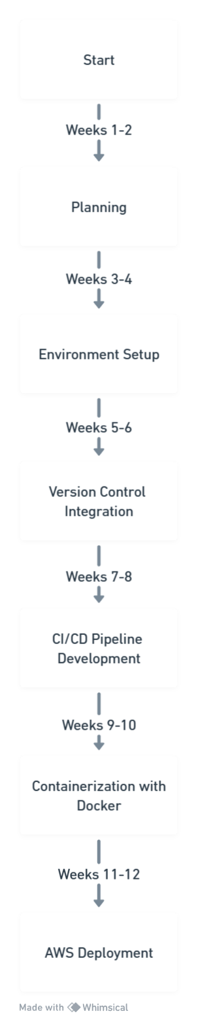

**1. Planning (Weeks 1-2):** The project begins with a two-week planning phase in which the team works together to determine the requirements, goals, and scope of the project. This stage involves in-depth conversations on job distribution, tool selection, and a careful analysis of the particular requirements of the AWS environment.

**2. Environment Setup (Weeks 3-4):** The development environment is built up in Weeks 3 and 4 after the planning phase. This comprises setting up AWS accounts, configuring GitHub repositories, and starting the basic components of the AWS architecture. The conclusion of the planning phase is one of the dependents throughout this phase.

**3. Version Control Integration (Weeks 5–6):** Using GitHub to integrate version control is the main emphasis of Weeks 5 and 6. The group works together to define branching methods, build a repository structure, and make sure version tracking facilitates smooth cooperation. This stage is essential for preserving the integrity of the code and encouraging effective teamwork.

**4. CI/CD Pipeline Development (Weeks 7-8):** Now that the version control system is operational, focus shifts to utilizing Jenkins to create CI/CD (continuous integration and deployment) pipelines. Writing automation scripts, setting up build procedures, and putting automated testing into practice take up weeks seven and eight. The project's overall efficiency is greatly enhanced by the successful completion of this phase, which guarantees an automated and dependable deployment procedure.

**5. Containerization with Docker (Weeks 9–10):** The application of containerization with Docker is scheduled for Weeks 9 and 10. The group's main tasks include establishing container setups, building Docker files, and making sure that everything works in different contexts. The project's consistency and scalability are improved with the successful conclusion of this phase.

**6. AWS Deployment (Weeks 11–12):** Setting up the web application on the AWS platform is the main focus of this last stage. This includes deploying Infrastructure as Code (IaC) with technologies like AWS CloudFormation. After this phase was completed successfully, the project came to an end. The web application is now hosted on AWS and has access to a fully automated DevOps pipeline.

**Importance of Every Stage:**

Planning: Establishes the framework by outlining the goals and scope of the project.

Environment Setup: Provides the basic framework needed for growth.

Effective cooperation and version tracking are ensured via version control integration.

Development of CI/CD Pipelines: Automates continuous integration and deployment.

Docker-based containerization improves consistency and scalability.

AWS Deployment: This step results in the web application being successfully deployed to AWS.

To sum up, the Gantt chart offers a comprehensive plan for implementing DevOps, stressing the interconnectedness of every stage and their crucial function in realizing an automated and smooth software delivery pipeline on the AWS platform.

# Introduction

## Context:

Embracing DevOps principles has become essential to breaking down the old divisions between development and operations teams in the dynamic world of contemporary software development. DevOps is a cultural movement that prioritizes cooperation, communication, and automation in order to produce high-quality software quickly and reliably. It is not just a collection of technologies or processes.

This report's backdrop explores the origins of DevOps, following its development from the necessity to handle the problems caused by the old waterfall model and subsequently Agile techniques. Combining development with operations, the term "DevOps" highlights the need of removing organizational boundaries and promoting shared accountability for the full software development lifecycle. This background lays the groundwork for realizing the significant influence that DevOps may have on raising productivity, cutting time to market, and boosting overall software quality.

## Business situation/Problem:

In the ever-changing field of software development, our project aims to solve a particular business situation or issue, namely the requirement for an efficient deployment procedure. During the deployment stage of traditional development approaches, bottlenecks frequently occur, causing delays, mistakes, and higher operational overhead. Our project intends to transform the software delivery pipeline by implementing a complete DevOps solution in recognition of this difficulty.

The stated issue is that the current deployment methods are inefficient, which makes it difficult to respond and act with the agility needed in the fast-paced business climate of today. This research undertakes a thorough investigation of these issues, examining the ways in which a weak DevOps pipeline may affect the development cycle, raise the possibility of mistakes, and obstruct the scalability of apps.

## Aims and Objectives:

Our DevOps implementation has well-defined goals that are in line with the main purpose of building a reliable and automated software delivery pipeline. The primary objective is to optimize the software development lifecycle's efficiency. Among the specific goals are:

**Establishing a Sturdy Pipeline:** Create and execute a DevOps pipeline that fits in well with the development workflow, guaranteeing a seamless changeover from code commit to production deployment.

**Version Control:** To improve teamwork, monitor modifications, and preserve code integrity, use version control using GitHub.

**CI/CD Automation:** Use Jenkins to automate the build, test, and deployment phases of continuous integration and continuous deployment (CI/CD) operations. This will minimize manual involvement and guarantee a dependable release cycle.

**Containerization:** To achieve consistency between development, testing, and production environments, use Docker for containerization.

**AWS Deployment:** Apply the Infrastructure as Code (IaC) concepts to leverage AWS as the cloud platform for hosting, deploying, and scaling the web application.

Together, these goals seek to revolutionize the development lifecycle by placing a premium on dependability, speed, and teamwork.

## DevOps Solution:

Our suggested DevOps solution, in its broadest sense, entails the fusion of essential technologies and procedures to optimize the software delivery process. Version control is based on GitHub, which promotes version tracking and collaborative development. Jenkins serves as the CI/CD orchestrator, automating every step of the process—from deployment to code integration—to guarantee consistency and dependability.

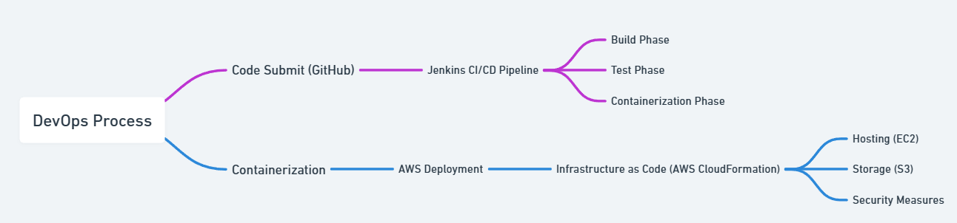

For containerization, Docker is introduced, which encapsulates the program and its dependencies and facilitates consistent deployment in a variety of settings. Ultimately, the cloud platform of choice is Amazon Web Services (AWS), which provides scalability, dependability, and a range of services for hosting and launching the web application. In this part, the DevOps solution is briefly but thoroughly reviewed, with a focus on the integration of GitHub, Jenkins, Docker, and AWS. The report's latter parts will go into further detail on the approach, results, and implementation methods used to demonstrate how DevOps principles may revolutionize AWS-based web application development.

# Methodology

## a. Project/Application Description

Our project's main feature is a cutting-edge e-commerce platform that has been painstakingly designed to simplify the online buying process. This online application functions as a virtual marketplace, providing users with an easy-to-use interface that streamlines the process of exploring, choosing, and securely processing products. A secure checkout procedure, an effective shopping cart system, and a fluid browsing experience are among the key features.

Our program incorporates sophisticated features that go beyond standard e-commerce functionality in order to improve customer pleasure and engagement. A crucial component is user account management, which lets users maintain preferences, track order histories, and establish and manage unique accounts. This creates the groundwork for fostering consumer loyalty while also making tailored buying easier.

Apart from transaction facilitation, the program integrates an intelligent recommendation system that is tailored to the preferences of the user. The system customizes product recommendations based on unique customer behaviours and interests by utilizing machine learning and data analytics, making the shopping experience more engaging and customized.

This web application's main goal is to provide a cutting-edge, scalable, dependable, and secure e-commerce solution. To handle fluctuating user traffic volumes and maintain the platform's performance during peak times, scalability is essential. Ensuring uninterrupted service is contingent upon reliability, while security measures are put in place to protect customer data and transactions.

To sum up, our e-commerce platform satisfies the essential needs for online purchasing while also including cutting-edge technologies to improve customer experience. Our objective is to provide a comprehensive e-commerce solution that meets the demands of contemporary customers and promotes long-term customer happiness, with an emphasis on scalability, stability, and security.

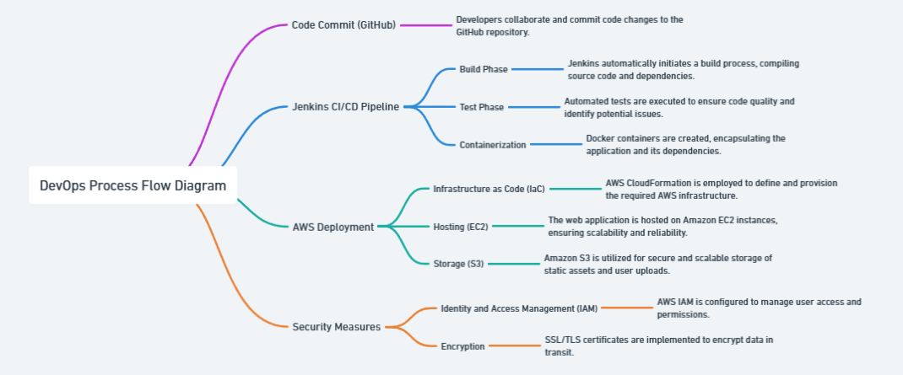

The DevOps Process Flow Diagram illustrates how important DevOps principles are seamlessly integrated and provides a visual depiction of the whole deployment process. Code development to deployment on the chosen AWS platform is made efficient and automated by this end-to-end approach. A thorough description of every stage is included with the graphic, highlighting the importance of each one in the entire procedure.

**1. Code submit (GitHub):** We work together to submit code changes to the GitHub repository, which starts the process. The popular version control program GitHub offers a centralized platform for code hosting, version tracking, and pull request administration, which promotes collaborative development.

**2. Jenkins CI/CD Pipeline:** The Continuous Integration and Continuous Deployment (CI/CD) pipeline is managed by Jenkins, our automation server of choice. There are three significant steps that comprise this phase:

**Build Phase:** Jenkins assembles source code and its dependencies automatically as part of the build process. This stage fixes dependencies, guarantees proper compilation of the program, and gets it ready for testing and deployment.

**Test Phase:** Automated tests are run to confirm the code's quality and functioning. This stage is essential for encouraging code stability by seeing any problems early in the development lifecycle.

**Containerization:** The program and its dependencies are contained within Docker containers, which is how containerization works. This phase streamlines the deployment process and guarantees consistency across many settings.

**AWS Deployment:** The next phase entails setting up the web application on the AWS infrastructure. This stage includes:

**Infrastructure as Code (IaC):** To describe and provision the required AWS infrastructure in a programmable and automated way, AWS CloudFormation is used. By using this method, human configuration mistakes are decreased and repeatability is increased.

**Hosting (EC2):** Scalable computational resources are provided by Amazon EC2 instances, which act as the web application's hosting environment. This guarantees peak efficiency and dependability, enabling the application to grow in response to demand.

**Storage (S3):** User uploads and static assets are safely stored using Amazon S3, a scalable object storage service. This keeps everything safe while improving data durability and availability.

**Security Measures:** To guarantee the confidentiality, integrity, and availability of the application, security measures are incorporated throughout the deployment process. This comprises:

**Identity and Access Management (IAM):** AWS IAM is set up to control user rights and access, upholding the least privilege principle and strengthening security in general.

**Encryption:** To protect sensitive data during user-application communication, SSL/TLS certificates are used to encrypt data in transit.

**Docker Security Best Practices:** By following best practices, Docker containerization reduces vulnerabilities and guarantees a safe runtime environment for the program.

In conclusion, the DevOps process flow diagram emphasizes automation, teamwork, and security across the software development lifecycle, showcasing the integration of essential DevOps techniques. Every phase helps to build an e-commerce solution that is safe, dependable, and scalable while adhering to industry best practices and guaranteeing a smooth deployment on the AWS platform.

## Cloud Platform

Our choice of Amazon Web capabilities (AWS) as our cloud platform is based on its extensive service portfolio, unmatched scalability, and strong infrastructure capabilities. Amazon offers a scalable and reasonably priced solution that easily fits the unique needs of our project. Our project takes use of AWS's dynamic capabilities by utilizing its vast spectrum of services.

Our computing architecture is built on Amazon EC2, which provides virtual servers that effectively host and scale our web application. By doing this, optimum performance and responsiveness to changing user loads are guaranteed. In addition to EC2, Amazon S3 is used as a scalable object storage solution for static files, ensuring file durability and acting as a safe haven for assets like user uploads and photographs. Essentially, AWS serves not just our short-term hosting requirements but also establishes the framework for a robust and scalable cloud architecture that facilitates the implementation and expansion of our e-commerce platform.

## Version Control Process and Proposed Tool

Due of its extensive user base, abundance of features, and ability to integrate seamlessly with Continuous Integration/Continuous Deployment (CI/CD) platforms, GitHub is chosen as the version control technology. The choice was based on GitHub's capacity to support teamwork in development, allowing several developers to work on the same codebase at the same time. One standout feature that simplifies the code review process is the pull request system of the platform. This approach minimizes mistakes and promotes code quality by ensuring that modifications are thoroughly reviewed before being integrated into the main branch.

GitHub is a widely used version control platform in the software development community. It provides a centralized repository for collaborative code, version tracking, and all-inclusive project management. Its powerful capabilities, which facilitate a cooperative and effective version control process throughout the development lifecycle, including branching strategies, issue tracking, and interaction with many development tools, precisely match the requirements of our project.

## Build/Test Process and Tool with Jenkins Pipeline

Jenkins is a popular open-source automation server that we use in our DevOps pipeline for automated testing and continuous integration. Jenkins is essential in automating the build and test procedures, guaranteeing that the deployment pipeline contains only code of the highest caliber.

The following crucial steps are coordinated by the Jenkins pipeline script that Groovy provides:

**Build Stage:**

Jenkins starts the Maven application compilation during the "Build" stage. In order to guarantee a clean build environment and install required dependencies, the mvn clean install command is run.

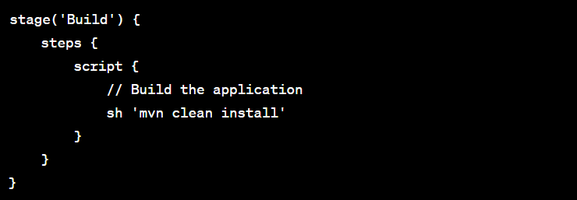

**Test Stage:**

After the build phase, automated tests are conducted to confirm that the application functions as intended during the "Test" stage. By guaranteeing that the specified tests are run, the mvn test command finds possible problems and regressions.

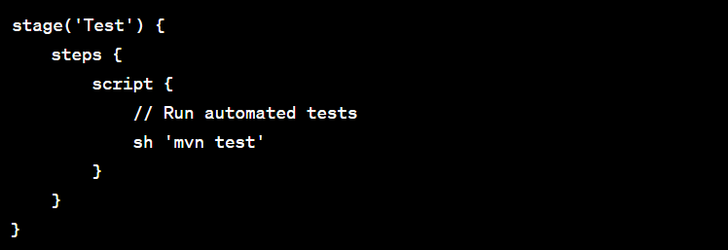

**Deployment Trigger:**

The post section contains a condition that, in the event that both the build and test phases are successful, initiates the deployment process (deployToAWS()). This guarantees that only code that has been successfully developed and extensively tested may move on to the deployment stage.

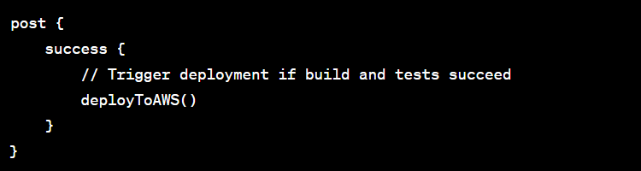

## Deployment Function:

The next stages in the deployment process are represented by the deployToAWS() function, which is called when the build and tests are successful. This function offers a placeholder for adding deployment-specific tasks, but it does not explain the actual deployment procedures.

The deployment step is described with the introduction of the "Deploy to AWS" stage.

AWS deployment stages are placeholders that are included in the deployToAWS() method. The placeholders (<YOUR_ACCESS_KEY>, <YOUR_SECRET_KEY>, <YOUR_AWS_REGION>, your-s3-bucket) should be changed by developers to reflect their real AWS credentials and deployment setup.

A simple example of deploying the application JAR file to an S3 bucket is shown via the AWS CLI instructions in the deployToAWS() method. These commands should be altered by developers in accordance with their own deployment objectives and specifications.

The build, test, and deployment phases are now included in this improved Jenkins pipeline script, providing a complete end-to-end automation process for the web application. The deployment procedures may be altered by developers to fit their deployment strategy and AWS environment.

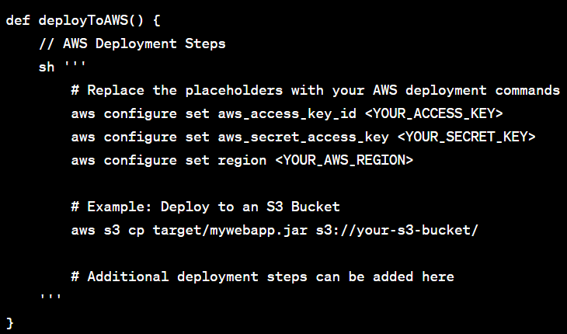

## Containerization Process with Docker

Containerization, a crucial technique that improves the consistency and portability of the web application across many environments, from development to production, is introduced via the integration of Docker into our DevOps process. In order to ensure that the program runs consistently independent of the underlying host system, Docker encapsulates the application and its dependencies inside a container. The environment, dependencies, and instructions for execution are all specified in the Dockerfile, which is essential for setting the setup of the container.

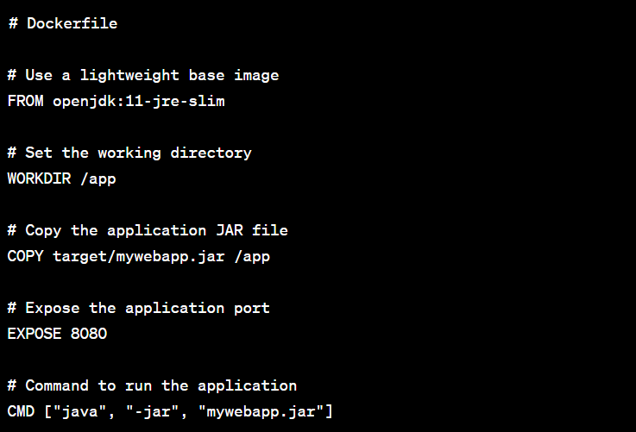

# An explanation of Dockerfiles:

**Base Graphic:**

The usage of a lightweight OpenJDK 11 runtime environment as the base image is indicated by the FROM openjdk:11-jre-slim line. Faster deployment and a reduced container size are achieved by using a thin base image.

**Operational Catalog:**

By setting the working directory inside the container to /app, the WORKDIR /app line makes following commands easier to understand and provides a consistent context.

**Make a copy of the application JAR:**

The application's built JAR file is copied into the container's working directory using the COPY target/mywebapp.jar /app line. This guarantees that the program is contained in the container with the most recent version.

**Open Port:**

Docker is informed that the application running within the container will be using port 8080 via the EXPOSE 8080 line. This records the intended network ports for future reference, even if it doesn't publish the port outside.

**Key to Launch the Program:**

The command to launch the Java application within the container is specified by the CMD ["java", "-jar", "mywebapp.jar"] line. Using the Java runtime, this command starts the application's JAR file.

## Best Practices for Containerization:

**Cutting Down on Layers:**

The Dockerfile follows industry best practices by keeping the number of layers to a minimum. In a Dockerfile, a new layer is created by each line. Layer minimization decreases container size and enhances build efficiency.

**Employing Minimal Base Images:**

It is in accordance with recommended practices to use lightweight base images that openjdk:11-jre-slim was selected as the basis image. These photos are designed with specific uses in mind, encouraging effectiveness and economical use of resources.

Consistency in development, testing, and production is ensured by encapsulating the complete runtime environment in the Dockerfile and using Docker's containerization. This method adds to the overall effectiveness and dependability of the DevOps pipeline by facilitating smooth team cooperation and streamlining the deployment process. With the knowledge that the containerized program will function reliably in any environment that supports Docker, developers may implement it with confidence.

# Security Issues and Mitigation Strategies in AWS and DevOps

It is critical to guarantee the security of a web application controlled by DevOps and delivered via AWS in order to guard against potential attacks and vulnerabilities. In order to strengthen the security posture of the deployed web application, this section lists important security factors and suggests practical mitigation techniques.

**1. Security Policies for Identity and Access Management (IAM):**

Problem: Inadequate IAM controls might allow for illegal access, which could jeopardize private information and resources.

Mitigation: Assign the minimal amount of permissions required in order to comply with the least privilege concept. Continually review and revise IAM policies to conform to changing access needs. To add even more protection, make multi-factor authentication (MFA) mandatory.

**SSL/TLS Security:**

Problem: Sensitive information may be exposed while in transit if encryption isn't used, increasing the possibility of data interception and illegal access.

Mitigation: Encrypt data when users and the application are communicating by putting SSL/TLS certificates into place. This guarantees end-to-end encryption, protecting private data from possible prying eyes.

**Security of Docker Containers:**

Problem: Security threats resulting from vulnerabilities in Docker containers might allow for unauthorized access or compromise of the containerized application.

Mitigation: To address known vulnerabilities, update base images on a regular basis. Apply vulnerability scans to Docker images to find and fix possible security flaws. Follow recommended measures for Docker security, such as utilizing minimum base images and minimizing superfluous rights.

**Security of CloudFormation:**

Problem: Unsecure CloudFormation scripts have the potential to cause AWS environment misconfigurations and expose confidential resources.

Mitigation: Check CloudFormation scripts for security best practices by validating and reviewing them. Use automated static analysis techniques to find possible misconfigurations. To make sure that CloudFormation templates are adhering to security requirements, do routine security audits and assessments.

**Example of Code:**

Here is an example IAM policy snippet that shows how the least privilege concept is put into practice:

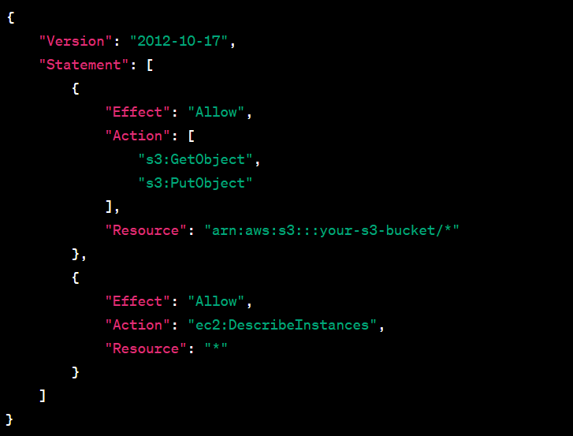

Here, IAM permissions are specifically set to only permit the operations that are required on certain resources (DescribeInstances in EC2, GetObject and PutObject in S3). As a result, there is less chance of unwanted access and the attack surface is decreased.

The total security of the deployed web application on AWS, which is maintained through DevOps processes, is greatly improved by taking these security factors into account and putting related mitigation strategies into effect. A strong security posture protects the application and its related data from possible attacks. Regular security assessments, upgrades, and adherence to best practices all contribute to this.

# Conclusion and Future Scope of DevOps Implementation

The software development lifecycle, deployment procedure, and general operational efficiency have all significantly improved as a result of our project's effective adoption of DevOps methods. The main conclusions and findings are outlined in this part, along with possible directions for future research and development to improve the DevOps workflow and deployment process even further.

**Important Results and Findings:**

Adopting DevOps methods has produced a number of important results and beneficial effects, as demonstrated by the thorough deployment of a DevOps pipeline:

***Simplified Method of Development:***

Rapid and dependable code release has been made possible by the development process's streamlining through the integration of continuous integration and continuous delivery (CI/CD) techniques. Automated build and test procedures reduce human intervention and mistake risk, which is beneficial to developers.

***Docker Environments That Are Consistent:***

Docker-based containerization has made environments uniform and portable across development and production phases. The dependencies of the program are defined in the Dockerfile, which guarantees that the application will always operate properly on the host machine. The development, testing, and operations teams work together more effectively when there is consistency.

***Effective AWS Implementation:***

Utilizing AWS as the cloud platform has shown to be successful in delivering infrastructure that is scalable, dependable, and economical. S3 for storage and EC2 for hosting are two AWS services that help create a stable deployment environment. The use of CloudFormation in the Infrastructure as Code (IaC) methodology improves repeatability and lowers the possibility of misconfigurations.

***Strengthened Security Protocols:***

A proactive approach to safeguarding the deployed web application is demonstrated by the detection and mitigation of any security risks. A stronger security posture is achieved by the combined use of IAM policies, SSL/TLS encryption, Docker container security, and CloudFormation security procedures.

***Effective AWS Implementation:***

Utilizing AWS as the cloud platform has shown to be successful in delivering infrastructure that is scalable, dependable, and economical. S3 for storage and EC2 for hosting are two AWS services that help create a stable deployment environment. The use of CloudFormation in the Infrastructure as Code (IaC) methodology improves repeatability and lowers the possibility of misconfigurations.

***Strengthened Security Protocols:***

A proactive approach to safeguarding the deployed web application is demonstrated by the detection and mitigation of any security risks. A stronger security posture is achieved by the combined use of IAM policies, SSL/TLS encryption, Docker container security, and CloudFormation security procedures.

## Future Scope:

Although there have been a lot of benefits from the existing DevOps implementation, there is still room for improvement in order to further strengthen the DevOps workflow and streamline the deployment process. The following categories show possible directions for further research and development:

**Putting Monitoring Tools Into Practice:**

Real-time insights into the functionality and condition of the deployed application may be obtained by integrating monitoring tools into the DevOps process. Prometheus and Amazon CloudWatch are two examples of tools that may be used to monitor important metrics, identify abnormalities, and provide proactive reactions to possible problems.

**Automated Infrastructure Scaling:**

Adding auto-scaling features to the AWS infrastructure can improve the system's capacity to manage fluctuating traffic volumes. To ensure best performance and resource efficiency, auto-scaling groups may be set up to automatically alter the number of EC2 instances based on demand.

**Improved Auditing and Logging:**

Robust visibility into system operations may be facilitated by fortifying the infrastructure and application's logging and auditing processes. ELK Stack (Elasticsearch, Logstash, and Kibana) and AWS CloudTrail are two examples of tools that may be used to track changes, consolidate logs, and assist with forensic analysis in the case of security problems.

**Integrating Extra Amazon Services:**

Additional AWS services can be investigated and integrated to better enhance the deployment process. Depending on the needs of the project, services like AWS Elastic Beanstalk for easier application deployment, Amazon RDS for managed relational databases, and AWS Lambda for serverless computing may be taken into consideration.

**Advanced Techniques for CI/CD:**

Using more complex testing techniques, including automated performance testing or security scanning, can help advance CI/CD processes. Further lowering deployment risk may be achieved by using blue-green deployments or canary releases, which enable slow rollouts and fast rollbacks in the event of problems.

**Integrating Extra Amazon Services:**

Additional AWS services can be investigated and integrated to better enhance the deployment process. Depending on the needs of the project, services like AWS Elastic Beanstalk for easier application deployment, Amazon RDS for managed relational databases, and AWS Lambda for serverless computing may be taken into consideration.

**Advanced Techniques for CI/CD:**

Using more complex testing techniques, including automated performance testing or security scanning, can help advance CI/CD processes. Further lowering deployment risk may be achieved by using blue-green deployments or canary releases, which enable slow rollouts and fast rollbacks in the event of problems.

**Constant Improvement and Learning:**

It is important to adopt a culture of ongoing learning and improvement. Ongoing improvements may be facilitated by conducting retrospective studies of deployment procedures, evaluating and upgrading DevOps methods on a regular basis, and remaining up to date on AWS best practices and new capabilities.

In summary, our project is now moving toward a software development lifecycle that is more effective, collaborative, and secure thanks to the effective application of DevOps methods. The future improvements that have been suggested provide a path for ongoing development, guaranteeing that the DevOps process will always be flexible enough to accommodate changing project needs and industry best practices. Our DevOps journey remains dynamic and iterative by embracing these future advancements, eventually helping to provide high-quality software solutions in a quickly changing technological context.

# Personal Reflections on DevOps Implementation

As a team member actively involved in our project's DevOps pipeline implementation, I consider the path, difficulties encountered, experiences with problem-solving, and personal development during this life-changing process.

**Challenges Faced:**

The DevOps implementation presented a number of difficulties that put our capacity for problem-solving and teamwork to the test. Since each team member brought a different set of skills to the table, one of the first problems was bringing the team's disparate skill sets together. Effective communication, information exchange, and a dedication to group learning were necessary to overcome this. In order to guarantee smooth transitions and compatibility, integrating diverse technologies and tools at different phases of the pipeline also required careful coordination.

**Experiences with Solving Problems:**

As we ran across problems ranging from complicated configurations to unforeseen integration glitches, problem-solving turned into a daily task. Optimizing Docker container build times, which were previously extended by needless dependencies, was one of the significant issues we encountered. By working together to discuss and study, we improved our Dockerfile, reduced the number of layers, and used lightweight base images to greatly increase build efficiency. This experience made it clear how crucial it is to continuously grow and explore when faced with obstacles.

Configuring IAM policies was a major additional issue. It took much thought to find a compromise between upholding the least privilege concept and granting the appropriate permissions for a smooth deployment. IAM policies that satisfied security and operational needs were crafted through frequent evaluations, debates, and iterative changes.

**Personal Development:**

Both professional and personal development were sparked by the DevOps journey. First off, I became more technically proficient because to the practical experience I had with industry-standard tools like Docker, AWS, and Jenkins. My expertise of scalable and safe software deployment techniques has expanded as a result of working with others on the architectural design and implementation phases.

Additionally, the deployment and continuous integration procedures gave code management a disciplined feel. In addition to increasing the dependability of our codebase, the shift-left methodology's emphasis on early testing and automation promoted a proactive problem avoidance mentality as opposed to reactive issue resolution.

My understanding of securing deployed apps has been much increased by being exposed to security issues in the DevOps process. My enthusiasm for the convergence of DevOps and cybersecurity has increased as a result of learning about the nuances of SSL/TLS encryption, IAM policies, and Docker container security. To successfully complete the project, teamwork and stakeholder communication were essential. DevOps's agile methodology required ongoing feedback loops and adaptable planning. Retrospectives, sprint reviews, and stand-ups on a regular basis helped me become more adept at working in a dynamic, iterative project environment.

To sum up, the process of implementing DevOps has been revolutionary, blending technical difficulties with significant opportunities for both personal and professional development. My exposure to industry-leading methods, problem-solving approach, and collaborative attitude have given me a comprehensive knowledge of DevOps concepts. As I think back on this trip, I have no doubt that the knowledge and abilities acquired will help this project succeed as well as provide a strong basis for future ventures in the always changing field of software development and deployment.

# References

Leite, L.; Rocha, C.; Kon, F.; Milojicic, D.; Meirelles, P. A Survey of DevOps Concepts and Challenges. ACM Comput. Surv. 2019,52, 1–35.

Jambunathan, B.; Kalpana, Y. Design of devops solution for managing multi cloud distributed environment. Int. J. Eng. Technol.2018, 7, 637–641.

Rafi, S.; Yu, W.; Akbar, M.A. RMDevOps: A road map for improvement in DevOps activities in context of software organi-zations.In Proceedings of the Evaluation and Assessment in Software Engineering, Trondheim, Norway, 15–17 April 2020; pp. 413–418.

Zarour, M.; Alhammad, N.; Alenezi, M.; Alsarayrah, K. Devops Process Model Adoption in Saudi Arabia: An Empirical Study.Jordanian J. Comput. Inf. Technol. 2020, 6, 3.

Akbar, M.A.; Rafi, S.; Alsanad, A.A.; Qadri, S.F.; Alsanad, A.; Alothaim, A. Toward Successful DevOps: A Decision-MakingFramework. IEEE Access 2022, 10, 51343–51362.

Ellen, L.; Riungu-Kalliosaari, L.; Mäkinen, S.; Lwakatare, L.E.; Tiihonen, J.; Männistö, T. DevOps Adoption Benefits and Challenges inPractice: A Case Study; Springer: Berlin/Heidelberg, Germany, 2016; pp. 590–597.

Soni, M. End to End Automation on Cloud with Build Pipeline: The Case for DevOps in Insurance Industry, ContinuousIntegration, Continuous Testing, and Continuous Delivery. In Proceedings of the 2015 IEEE International Conference on CloudComputing in Emerging Markets (CCEM), Bangalore, India, 25–27 November 2015; pp. 85–89.

Barna, C.; Khazaei, H.; Fokaefs, M.; Litoiu, M. Delivering elastic containerized cloud applications to enable DevOps. InProceedings of the 2017 IEEE/ACM 12th International Symposium on Software Engineering for Adaptive and Self-ManagingSystems (SEAMS), Buenos Aires, Argentina, 22–23 May 2017; pp. 65–75.

Guerriero, M.; Ciavotta, M.; Gibilisco, G.P.; Ardagna, D. SPACE4 Cloud: A DevOps Environment for Multi-cloud Applications.Short-Pap. In Proceedings of the 1st International Workshop on Quality-Aware DevOps, Bergamo, Italy, 28 May 2015; pp. 29–30.

Kang, H.; Yoonhee, J.K.; Rahm, J. A SLA Driven VM Auto-Scaling Method in Hybrid Cloud Environment. In Proceedings ofthe 2013 15th Asia-Pacific Network Operations and Management Symposium (APNOMS), Hiroshima, Japan, 25–27 September2013; pp. 25–30.

Li, Y.; Xia, Y. Auto-scaling web applications in hybrid cloud based on docker. In Proceedings of the 2016 5th InternationalConference on Computer Science and Network Technology (ICCSNT), Changchun, China, 10–11 December 2016; pp. 75–79.

Mor´n, D.; Vaquero, L.M.; Gal´n, F.; Moran, D.; Galán, F. Elastically Ruling the Cloud: Specifying Application’s Behavior inFederated Clouds. In Proceedings of the IEEE 4th International Conference on Cloud Computing,Washington, DC, USA, 4–9 July2011; pp. 89–96.

Ghari, S. Devops for digital business: Optimizing the performance and economic efficiency of software products for digitalbusiness. In Proceedings of the 17th Symposium on Software Engineering for Adaptive and Self-Managing Systems, Pittsburgh,PA, USA, 18–23 May 2022; pp. 53–57.

Tsilionis, K.; Sassenus, S.; Wautelet, Y. Determining the Benefits and Drawbacks of Agile (Scrum) and DevOps in Addressingthe Development Challenges of Cloud Applications. In Proceedings of the International Research & Innovation Forum, Athens,Greece, 15–17 April 2021; pp. 109–123.

Akbar, M.A.; Smolander, K.; Mahmood, S.; Alsanad, A. Toward successful DevSecOps in software development organizations: Adecision-making framework. Inf. Softw. Technol. 2022, 147, 106894.

Jaatun, M.G.; Cruzes, D.S.; Luna, J. DevOps for Better Software Security in the Cloud Invited Paper. In Proceedings of the 12thInternational Conference on Availability, Reliability and Security, Reggio Calabria, Italy, 28 August–1 September 2017; p. 69.